Project Management Plan
- Introduction: Purpose and Scope
This plan covers the development of a Moderated Learning Management System (LMS) for a secondary school, supporting four roles: administrators, lecturers, Heads of Department (HoDs) and students. Marks reach students only after HoD moderation, and every mark change is audit-logged.The project runs for seven weeks using the Waterfall model with V-Model verification. The system is a standalone, offline C++17 application with SQLite storage, supporting up to 800 students. Online payment, video conferencing, automated grading, plagiarism detection and web or mobile interfaces are out of scope.The plan presents the feasibility study, work breakdown structure, schedule and risk register, with assuming one developer starting on 01 October 2026.
- Feasibility Study
Dimension | Assessment | Verdict
Technical | The system is a standalone C++17 application that stores everything locally in SQLite, so it needs no internet, web service or cloud hosting. That suits the school's old computers and unreliable connection, and SQLite handles 800 students easily. Leaving out payments, video calls, automated grading, plagiarism checks and web or mobile apps keeps the toolset small (C++17, CMake, SQLite) and realistic for one person to build. | Feasible
Operational | Teachers aren't IT experts, so each of the four roles gets its own simple menu and sees only what it needs. Lecturers set assignments, grant extensions and mark work. HoDs check and approve marks before release. Students submit (or resubmit before the deadline) and see their marks and feedback once released. Every mark change is logged with who made it, when, the old and new values, and why. | Feasible
Economic | Everything needed is free and open source: the compiler, CMake, SQLite, GoogleTest or Catch2, cppcheck or clang-tidy, and Git. The system runs on computers the school already has, so there are no licences, hosting fees or subscriptions to pay. | Feasible
Legal, security and ethical | Passwords are never stored in plain text, only as salted hashes made with a recognised library. Students can't see any mark until the HoD has approved it. Late penalties, extensions and resubmissions follow fixed rules applied the same way to everyone, and the audit log lets the school show that marks were handled fairly. | Feasible with controls
Schedule | Seven weeks is tight for the whole life cycle. Working in clear phases, with supervisor reviews along the way, helps keep the scope under control, and Gate 2 prevents coding from starting before the design is approved. | Feasible if scope is controlled

Schedule Feasibility: Weekly Timeline
Weeks | Phase | Main activities
1-2 | Planning and requirements | Feasibility study, resolve stakeholder conflicts, SRS, use case models (Gate 1)
2-3 | System design | Architecture, detailed UML, design patterns, 3NF database schema (Gate 2)
4-5 | Implementation | Core C++17 logic, SQLite integration, CI pipeline
5-6 | Testing and QA | Automated unit and integration tests, coverage, system and acceptance testing (Gate 3)
6-7 | Deployment and finalisation | Packaging, user documentation, CR1 with regression testing, final report and viva

Recommendation
Item | Detail | Item
Decision | Proceed with development | Decision
Justification | Viable on all five dimensions. The standalone C++17 and SQLite design fits the legacy, offline environment at no licensing cost. The workflows resolve the stakeholder tension over mark moderation and extensions. Salted hashing and audit logging address security and ethics. | Justification
Condition | Manage the seven-week schedule strictly through the gates. | Condition

- Work Breakdown structures
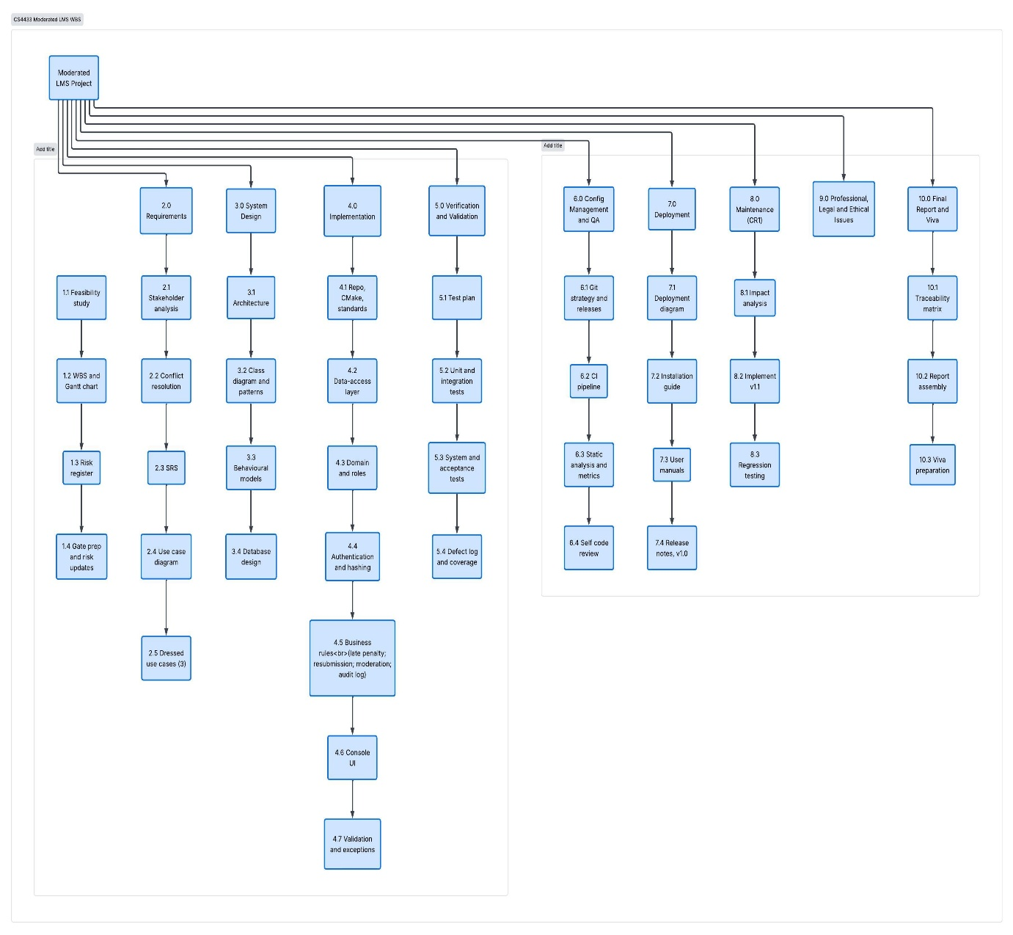

- Gantt Chart
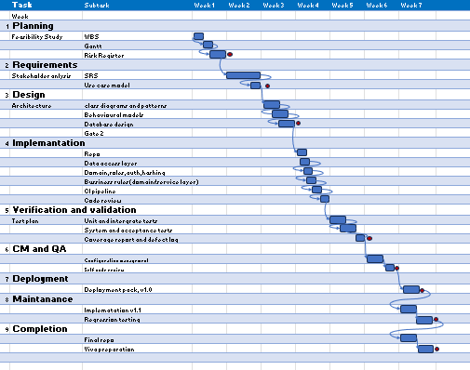

Critical Path
Feasibility → Stakeholder analysis → SRS → Architecture → Class diagram → Gate 2 → Repository/CI → Data-access layer → Domain, roles and security → Business rules → System and acceptance tests → Gate 3 → v1.0 release → CR1 analysis → v1.1 → Regression tests → Final report and viva preparation.

- Risk Register
Likelihood (L) and impact (I) are scored 1–5; exposure = L × I (≥15 high, 8–14 medium, ≤7 low).
Risk ID | Category | Risk description and cause | L | I | E | Mitigation strategy | Owner | Gate review / status
TR-01 | Technical | Database locking or SQL injection. Locking problems or injection vulnerabilities under heavy use by up to 800 students on legacy hardware. | 3 | 4 | 12 | Use parameterised SQL queries only, through the data-access layer. Handle SQLite connections safely and schedule automated database backups. | Student | Gate 1: validate DB requirements. Gate 2: audit ERD and schema. Gate 3: load-test DB queries.
TR-02 | Technical | Weak password security. Passwords stored unhashed or weakly hashed, breaching the security requirements and data privacy standards. | 2 | 5 | 10 | Use salted password hashing from a recognised library (e.g. bcrypt or Argon2). Add unit tests proving plain-text passwords are never stored. | Student | Gate 1: review security NFRs. Gate 2: review security architecture. Gate 3: verify hashing tests.
PR-01 | Project | Schedule slip at Gate 2. Late completion of the Phase 3 design delays Phase 4, because supervisor approval is needed before coding starts. | 4 | 4 | 16 | Prioritise MoSCoW "Must" requirements. Set up the CMake/C++ project scaffolding during Phase 3 so development can begin right after Gate 2. | Student | Gate 1: monitor SRS completion. Gate 2: gate approval check. Gate 3: N/A.
PR-02 | Project | Regression during CR1. Adding class-wide extensions in Phase 8 breaks the existing individual extension logic or the audit log. | 3 | 3 | 9 | Apply the Strategy and Repository patterns in the Phase 3 design. Keep unit test coverage at 70% or more in GoogleTest/Catch2, run through CI, to catch regressions. | Student | Gate 1: N/A. Gate 2: check design extensibility. Gate 3: verify test coverage.
HR-01 | People | Conflict over assessment policies. Disagreement between the HoD (10% per day penalty) and lecturers and students (extensions, resubmission) leads to flawed business logic. | 4 | 3 | 12 | Run formal stakeholder conflict resolution in Phase 2. Encapsulate the late-penalty rules with the Strategy pattern so they can change without altering core code. | Student | Gate 1: review conflict resolution. Gate 2: audit Strategy pattern design. Gate 3: validate penalty test cases.
HR-02 | People | User errors from complex navigation. Lecturers or HoDs make mistakes because the menus are too complicated, causing acceptance tests to fail. | 3 | 4 | 12 | Use role-based access control and strict input validation. Test usability with the fully dressed use case scenarios during Phase 5 system testing. | Student | Gate 1: review use case flows. Gate 2: review UI state diagrams. Gate 3: run acceptance scenarios.
PR-03 | Project | Inconsistent artefacts. The SRS, UML diagrams, SQLite schema, C++ classes and tests don't match, which costs marks. | 3 | 5 | 15 | Maintain a traceability matrix linking each functional requirement to its use case, class, database table, C++ file and test case. | Student | Gate 1: verify SRS to use case mapping. Gate 2: verify design to schema mapping. Gate 3: audit traceability matrix completion

- Management Approach
Progress will be monitored through a weekly self-review that compares work completed against the Gantt chart and the work breakdown structure, with the critical path checked first. The risk register will be re-scored at each of the three phase gates, and any risk with high exposure will trigger a revised mitigation. New or changed requirements will be handled through change control: each one is re-prioritised using MoSCoW and accepted only if it does not threaten a Must requirement or delay the critical path. To protect the work, all code and documents are pushed to a hosted Git repository daily, and a buffer is held in the final week to absorb slippage.

